**Stored Procedures**

**CODE :**

-- Create Accounts table

CREATE TABLE Accounts (

AccountID INT PRIMARY KEY,

AccountType VARCHAR(20),

Balance DECIMAL(10,2)

);

-- Insert sample accounts

INSERT INTO Accounts VALUES

(101, 'Savings', 5000.00),

(102, 'Savings', 10000.00),

(103, 'Checking', 3000.00);

-- Create Employees table

CREATE TABLE Employees (

EmployeeID INT PRIMARY KEY,

DepartmentID INT,

Salary DECIMAL(10,2)

);

-- Insert sample employees

INSERT INTO Employees VALUES

(1, 10, 40000.00),

(2, 10, 45000.00),

(3, 20, 50000.00);

DELIMITER //

CREATE PROCEDURE ProcessMonthlyInterest()

BEGIN

-- Add 1% interest to all savings accounts

UPDATE Accounts

SET Balance = Balance + (Balance * 0.01)

WHERE AccountType = 'Savings';

SELECT 'Monthly interest processed successfully.' AS Message;

END;

//

DELIMITER ;

DELIMITER //

CREATE PROCEDURE UpdateEmployeeBonus(

IN dept_id INT,

IN bonus_percent DECIMAL(5,2)

)

BEGIN

-- Add bonus to all employees in the given department

UPDATE Employees

SET Salary = Salary + (Salary * bonus_percent / 100)

WHERE DepartmentID = dept_id;

SELECT CONCAT('Bonus applied to department ', dept_id) AS Message;

END;

//

DELIMITER //

CREATE PROCEDURE TransferFunds(

IN from_account INT,

IN to_account INT,

IN amount DECIMAL(10,2)

)

BEGIN

DECLARE from_balance DECIMAL(10,2);

-- Get balance of source account

SELECT Balance INTO from_balance

FROM Accounts

WHERE AccountID = from_account;

-- Check balance and perform transfer

IF from_balance < amount THEN

SELECT 'Transfer failed: Insufficient balance.' AS Message;

ELSE

-- Deduct from source

UPDATE Accounts

SET Balance = Balance - amount

WHERE AccountID = from_account;

-- Add to destination

UPDATE Accounts

SET Balance = Balance + amount

WHERE AccountID = to_account;

SELECT 'Transfer successful!' AS Message;

END IF;

END;

//

DELIMITER ;

DELIMITER ;

CALL ProcessMonthlyInterest();

SELECT * FROM Accounts;

CALL UpdateEmployeeBonus(10, 10);

SELECT * FROM Employees;

CALL TransferFunds(102, 103, 2000);

SELECT * FROM Accounts;

SELECT * FROM employees;

**OUTPUT :**

SCENARIO - 1:

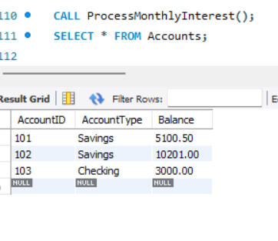

SCENARIO - 2 :

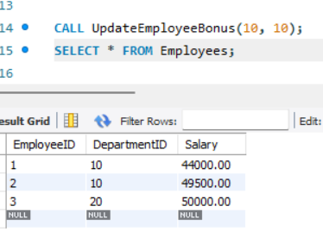

SCENARIO - 3 :

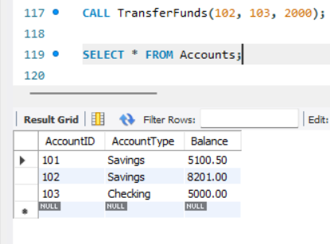

ACCOUNT TABLE :

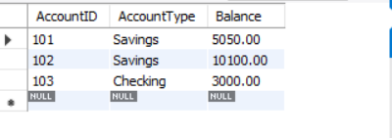

EMPLOYEE TABLE :

